FAZAIA BILQUIS COLLEGE OF EDUCATION FOR
WOMEN PAF NUR KHAN, RWP


Parallel Distributed Computing (LAB)
Lab 1 Tasks
Submitted to

Ma’am Iffat

Submitted by

Javeria Fazal
BSCS 7th B
F21-62

Task 1:
Write a method/function that inputs two numbers and displays sum, difference,multiplication,
division. Also handle the exception of zero in division.

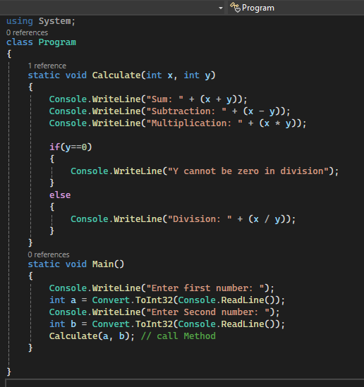
- Screenshot of Source Code:
Figure 1
- Output:
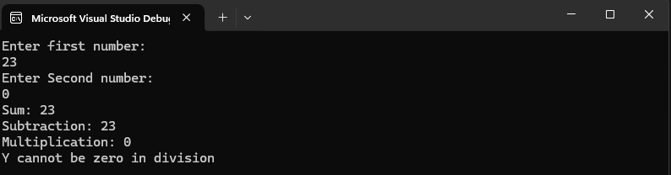
Figure 2 (a)
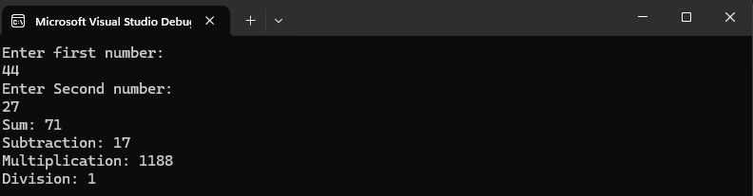
Figure 2(b)

Task 3
Finding the Factorial of a number.

- Source Code:

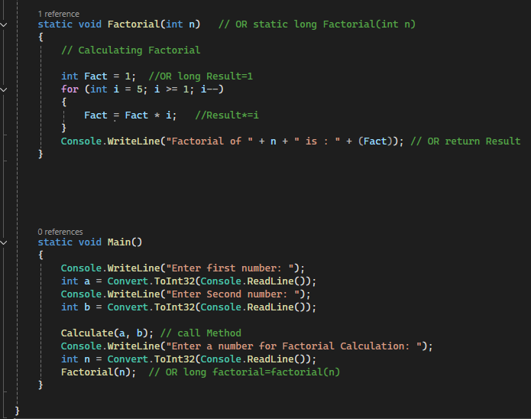
Figure 3

- Output:

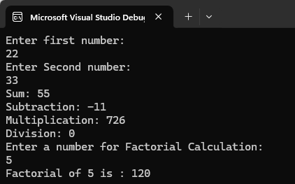
Figure 4

Task 4
Write a program to reverse the string.
- Source Code:

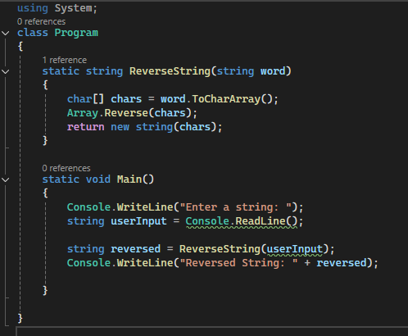

Figure 5

- Output:
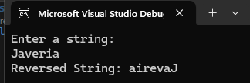

Figure 6

Task 5
1. Make a class P with int a = 30.
2. Make another class Q that extends P with int a = 50.
3. Create an object of Q and print a using that object.
4. Use a P (super-class) reference to point to the Q(sub-class) object and print a again.

- Source Code:
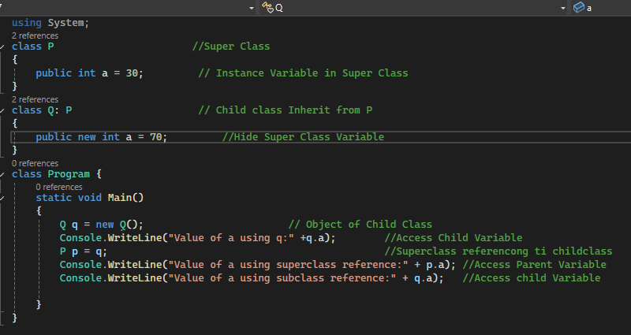
Figure 7

- Output:

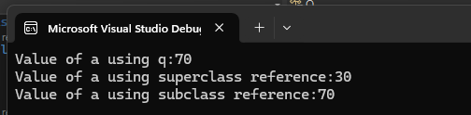

Figure 8

Task 6
1. using System.Threading namespace.
2. Write a method that counts from 1 to 10, printing each number with a short delay of 0.5 sec (Thread.Sleep).
3. In Main, create a Thread object for the counter method.Start the thread with Start().
4. Run reverse counter in another thread to observe parallel execution.

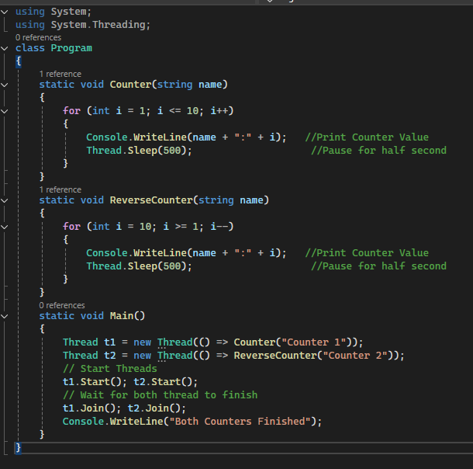
- Source Code:
Figure 9
- Output:(with a delay of 0.5 sec for each iteration)
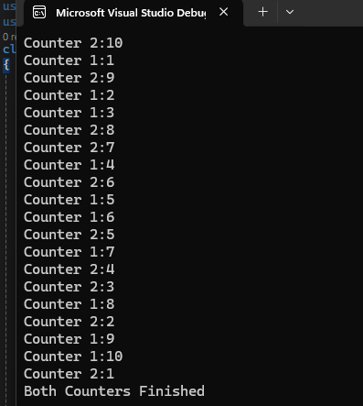

Figure 10
- Theory Class Program
2 threads each should print different message. Ensure both run concurrently.

- Source Code:

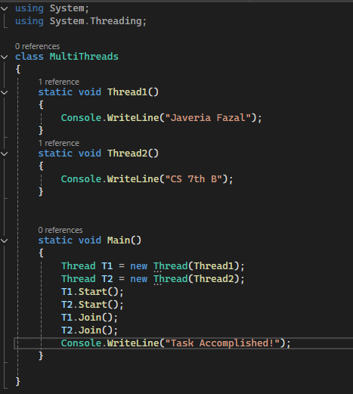
Figure 11

- Output:

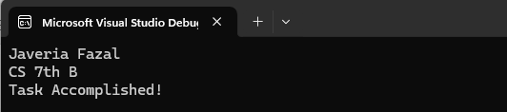
Figure 12

